SCREENSHOTS FOR MY CLASS WORK BASED OF TIME FUNCTIONS

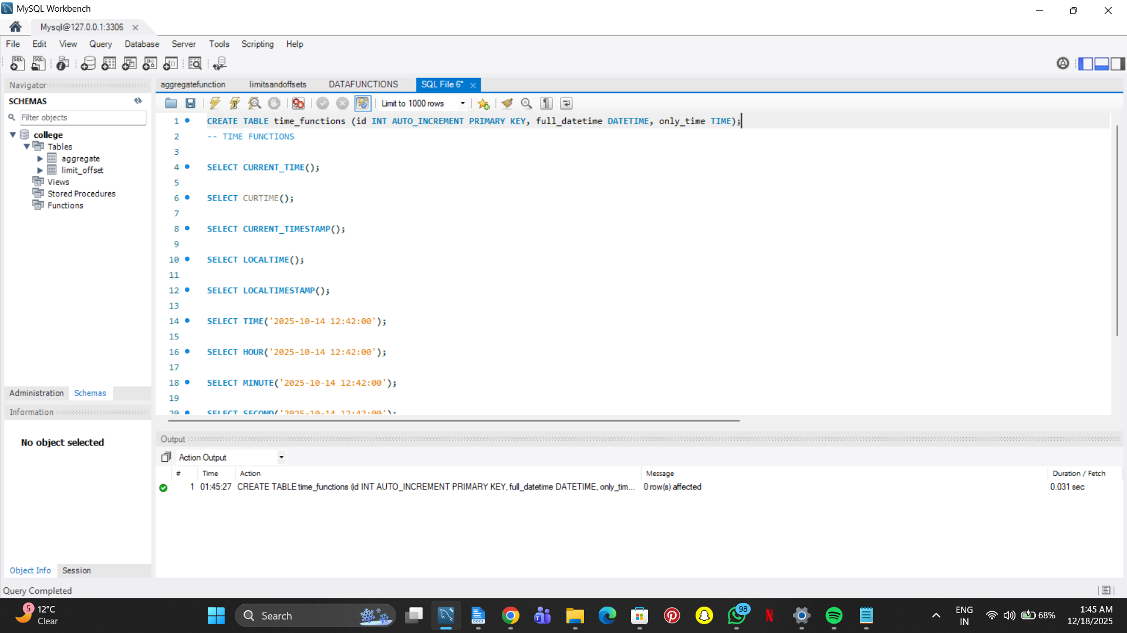

SELECT CURRENT_TIME();

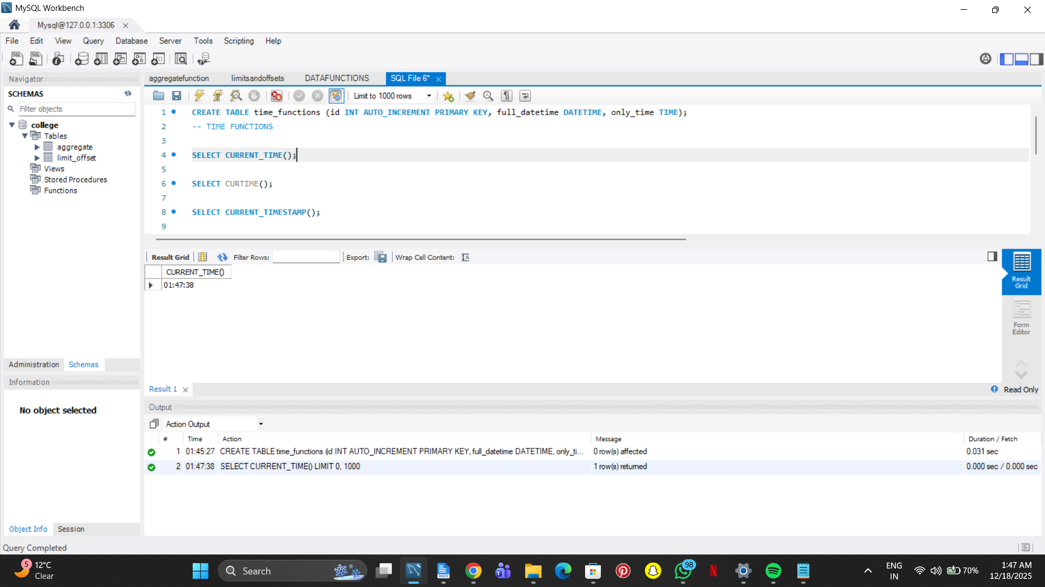

SELECT CURTIME();

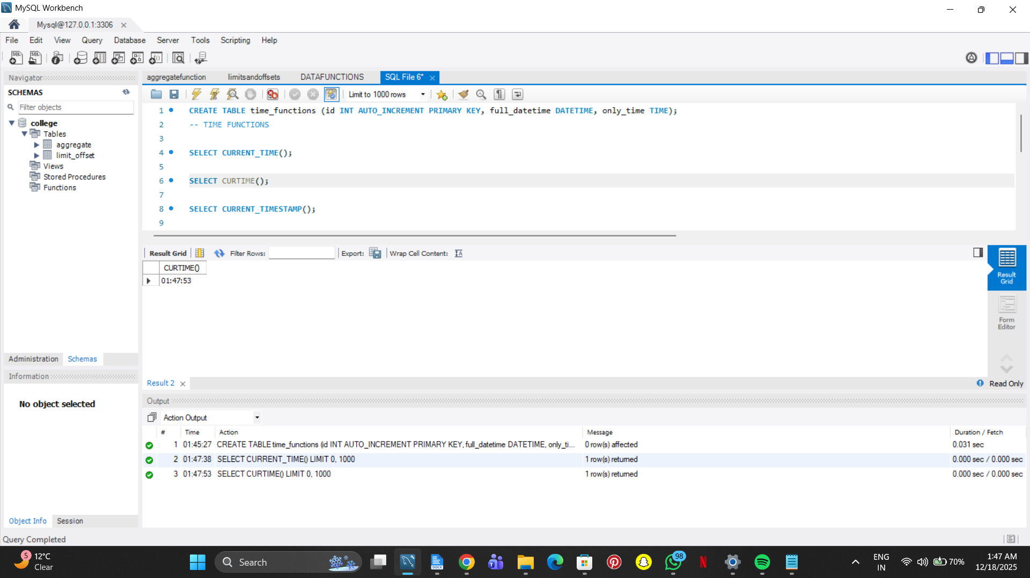

SELECT CURRENT_TIMESTAMP();

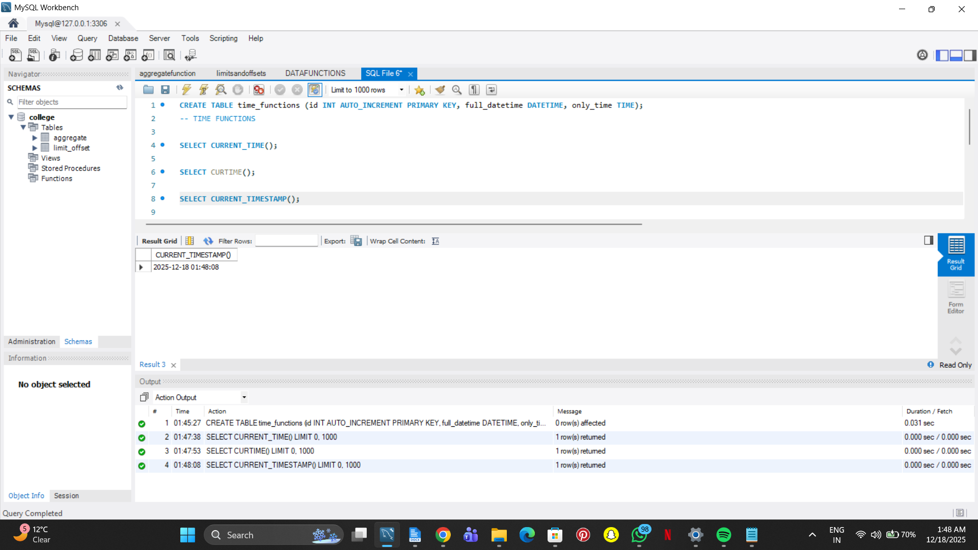

SELECT LOCALTIME();

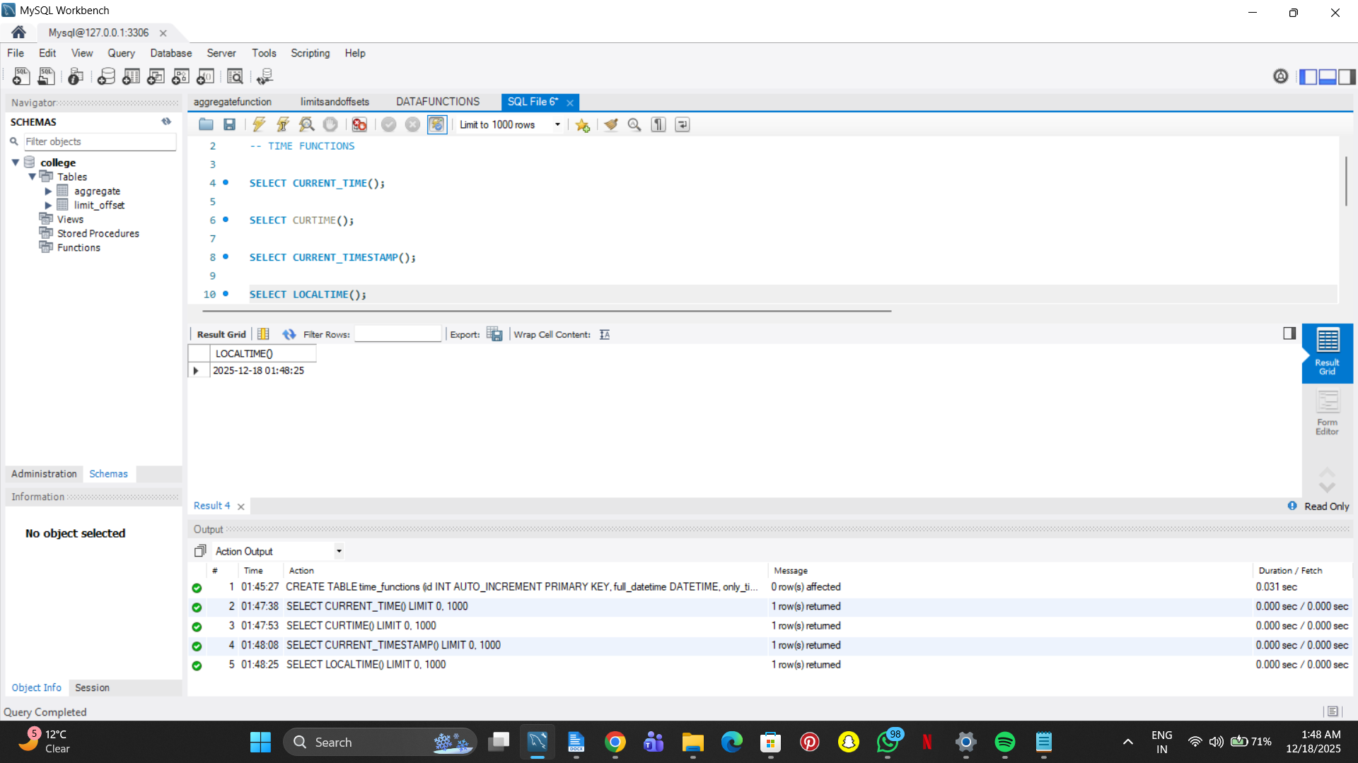

SELECT LOCALTIMESTAMP();

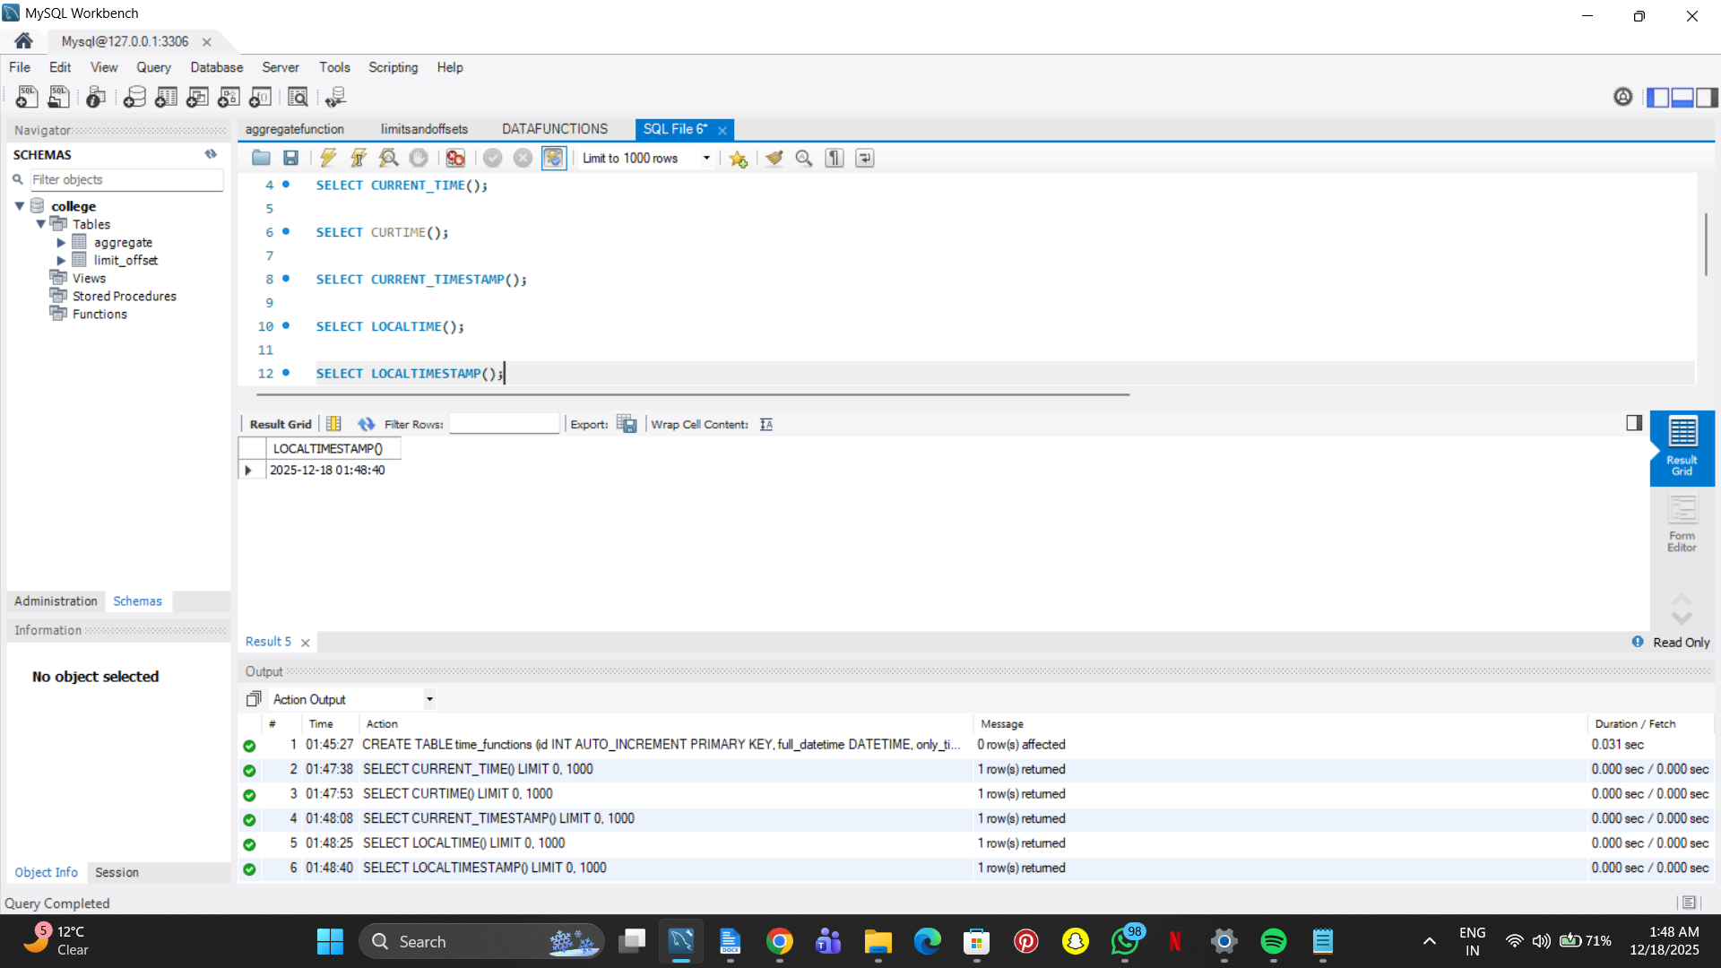

SELECT TIME('2025-10-14 12:42:00');

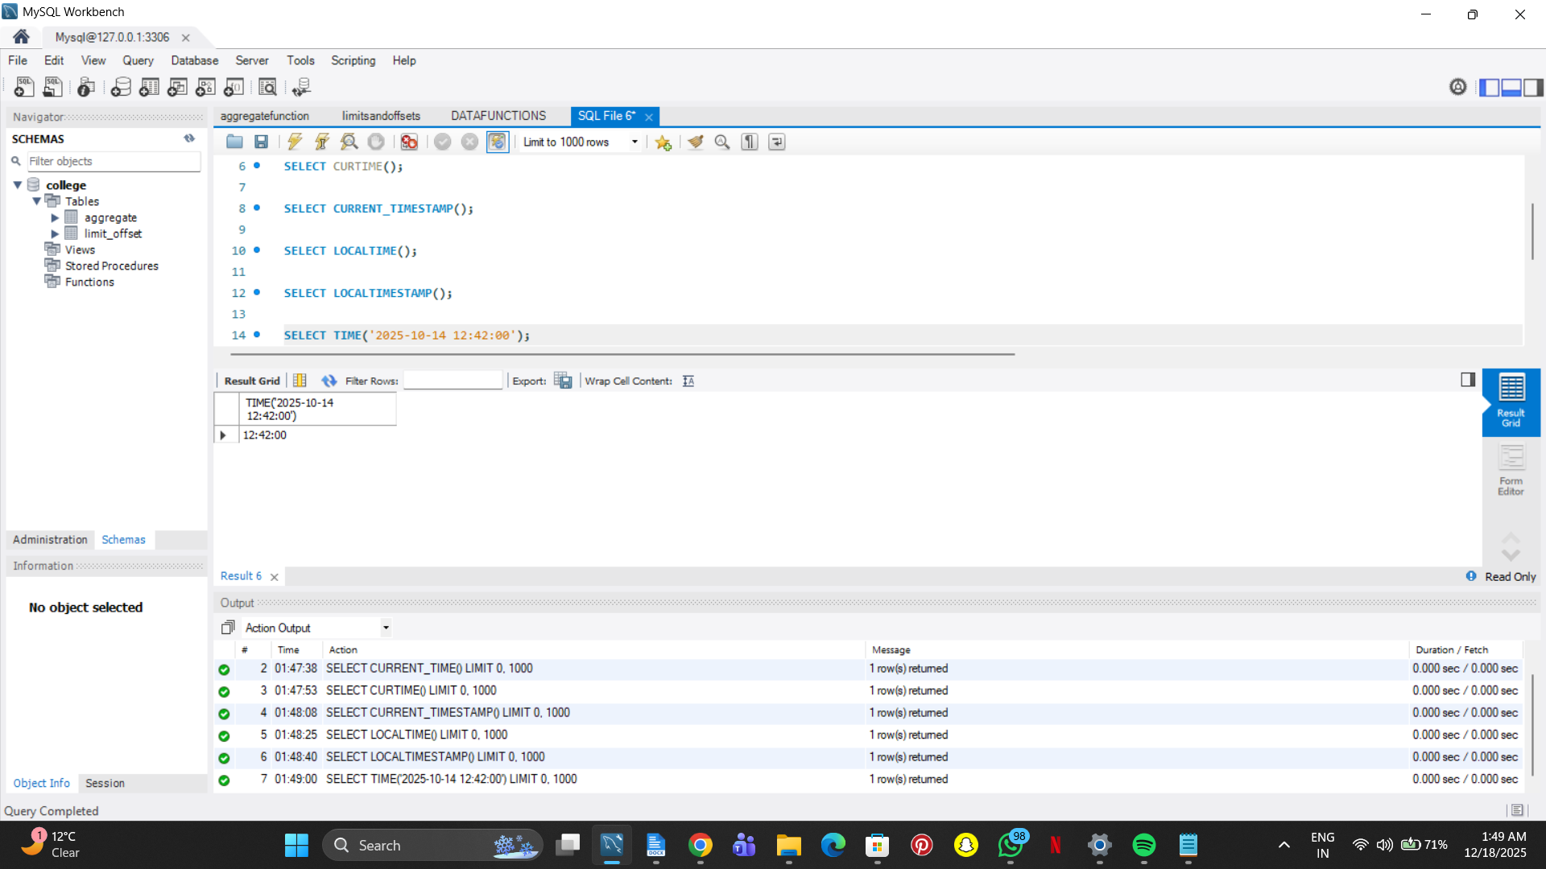

SELECT HOUR('2025-10-14 12:42:00');

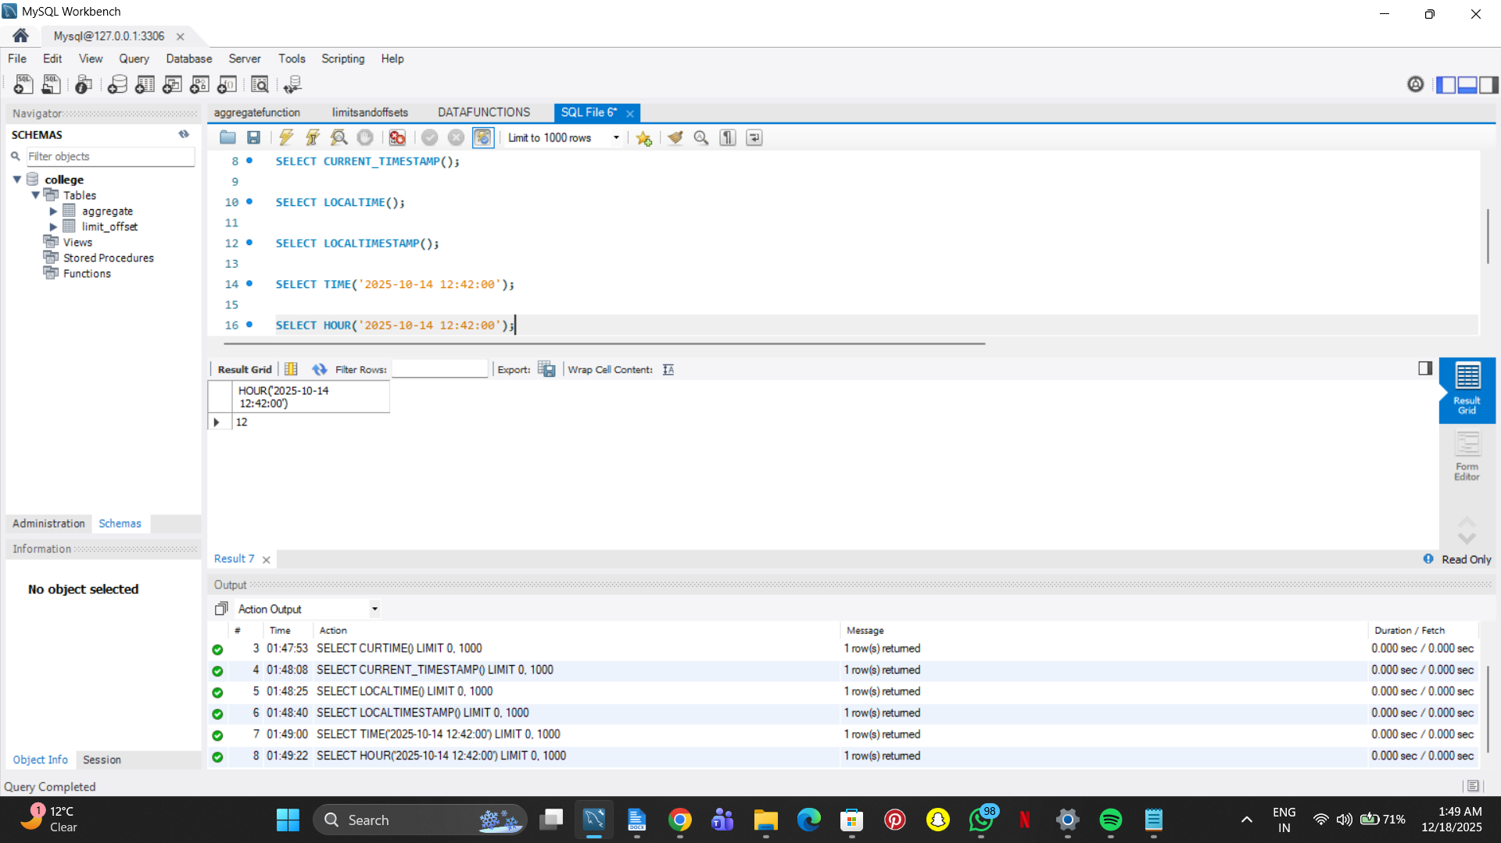

SELECT MINUTE('2025-10-14 12:42:00');

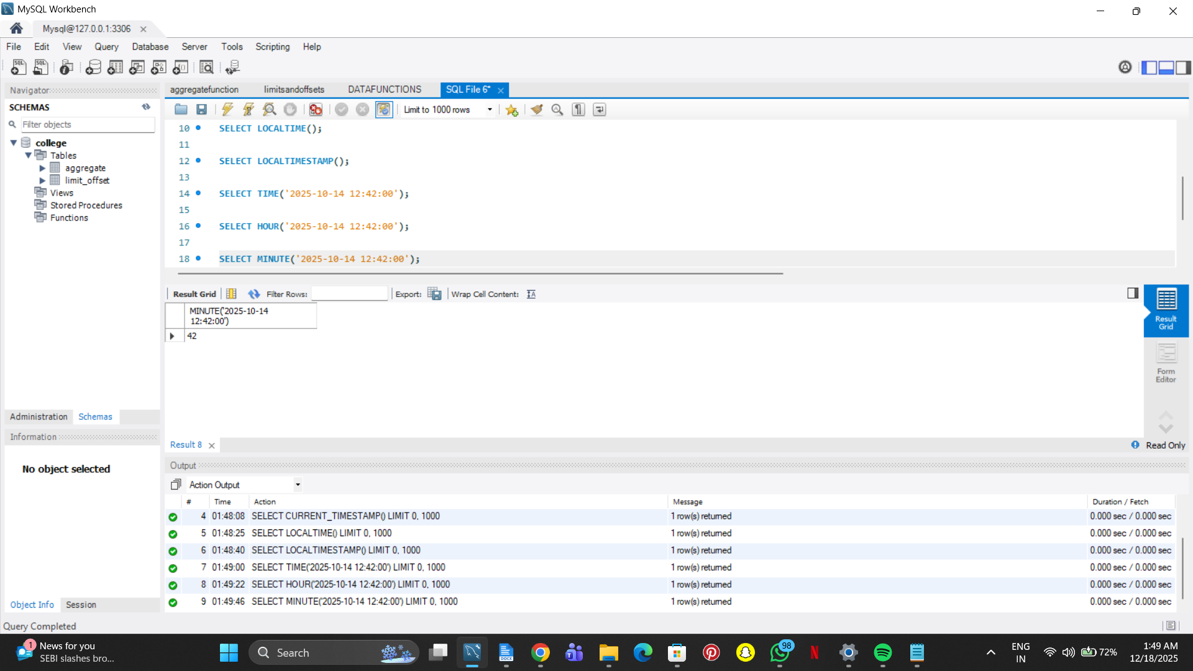

SELECT SECOND('2025-10-14 12:42:00');

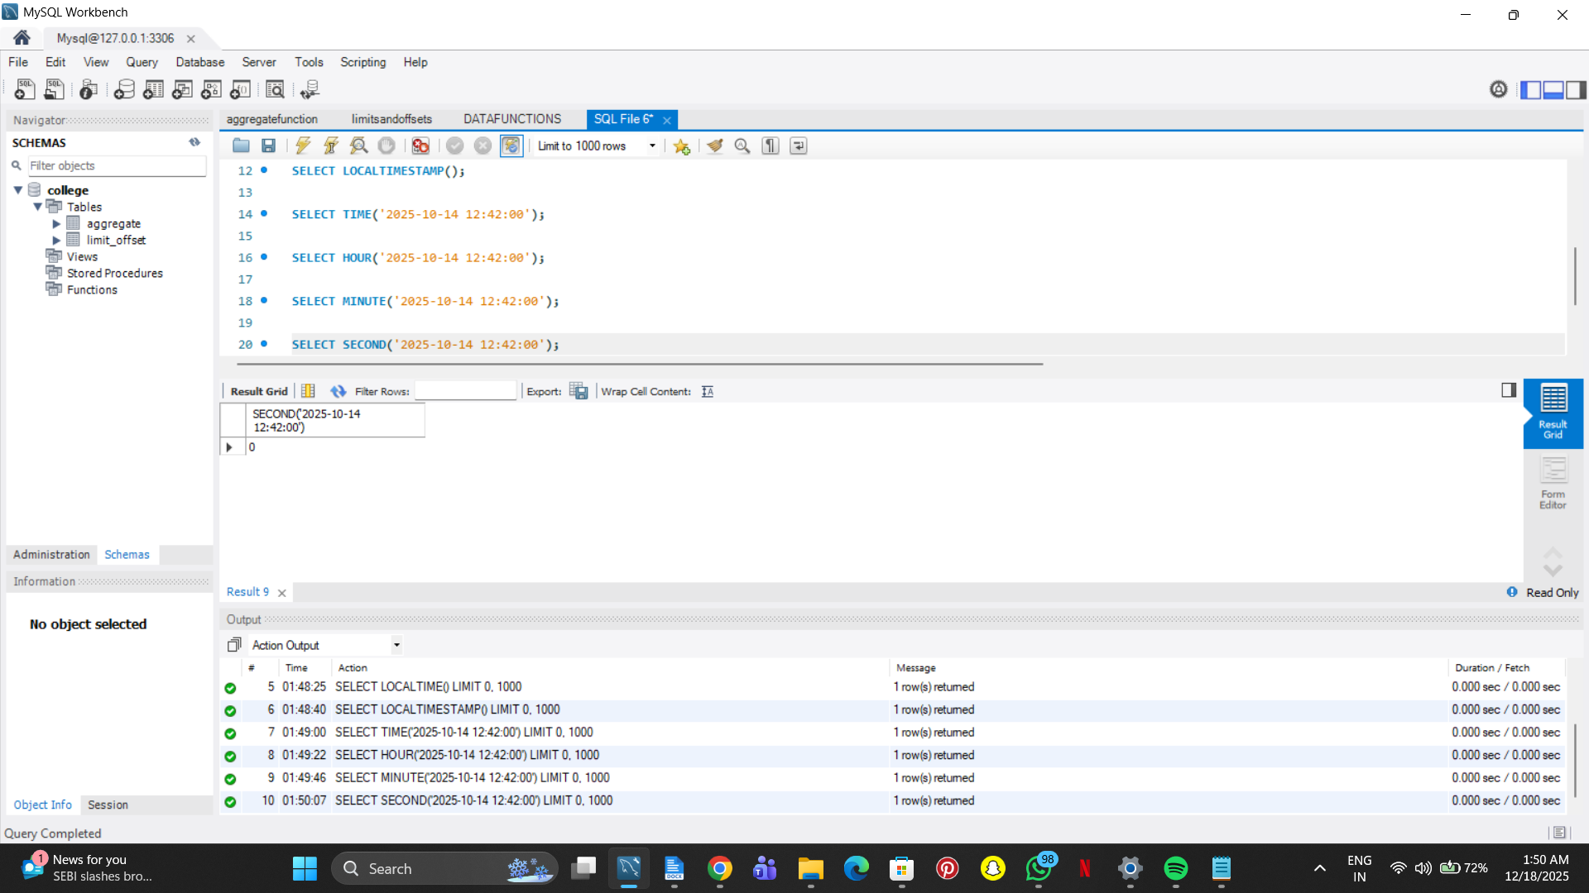

SELECT TIMEDIFF('12:42:00', '11:42:00');

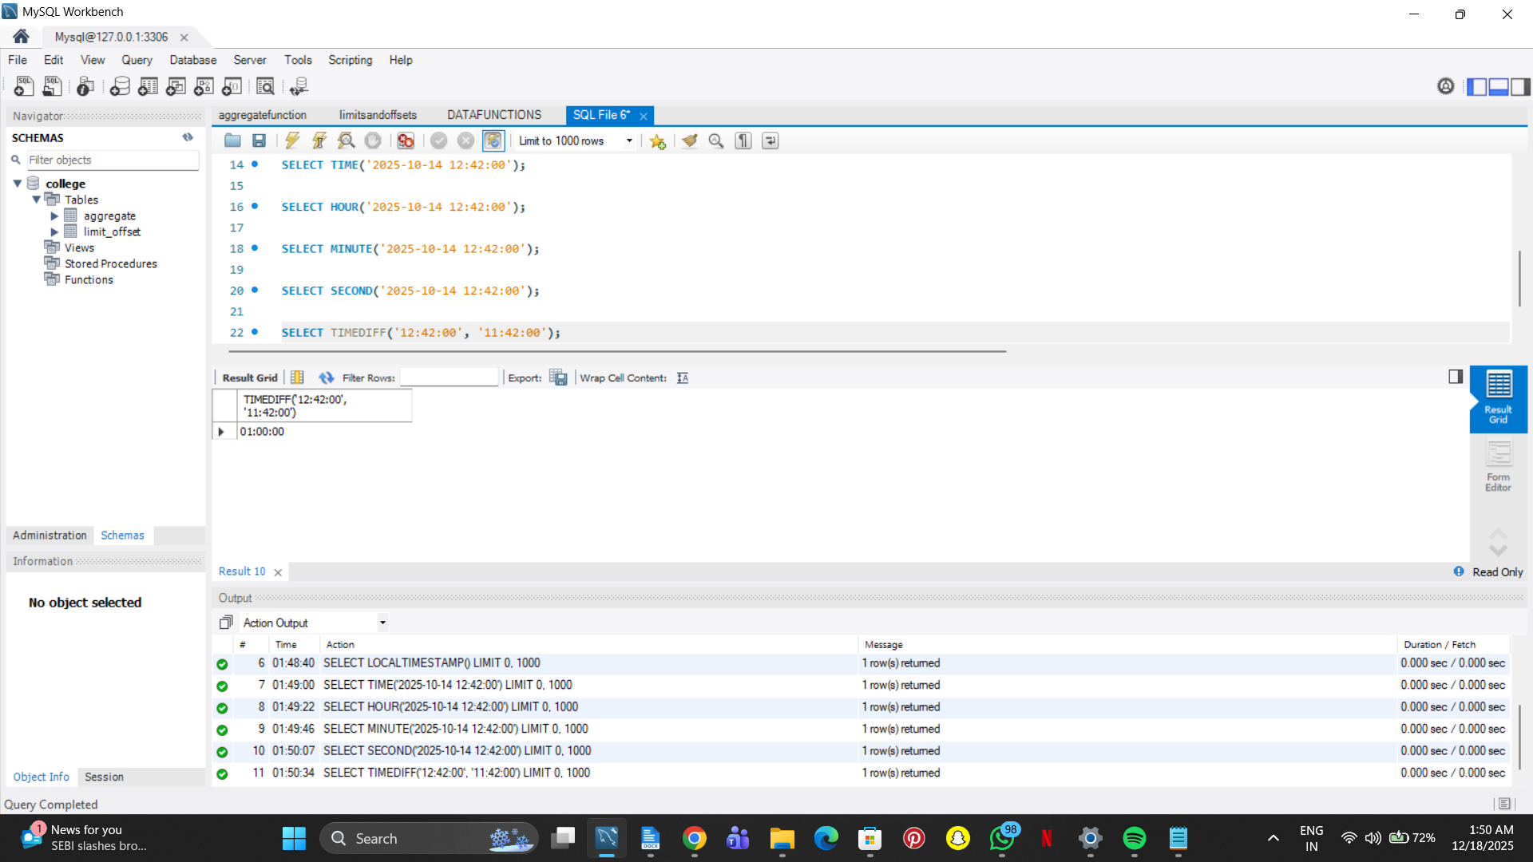

SELECT TIMEDIFF('12:42:00', '12:40:00');

